*LITTLE JOYS OF LIFE*

*Hey!! How are you??*

*Lockdown has made you sad, depressed and distressed. The negativity around this term is impacting almost everybody out there. People don't know how to face it and even in simple daily life, it seems too hard sometimes. It seems impossible to get happiness anywhere out there. The thoughts in head keep on corroding the inside happiness and a left over rusted soul is left. It's known that everybody goes through this type of phase many times. But what arises as the problem is that they don't know how to come out of it, how to find this happiness again.*

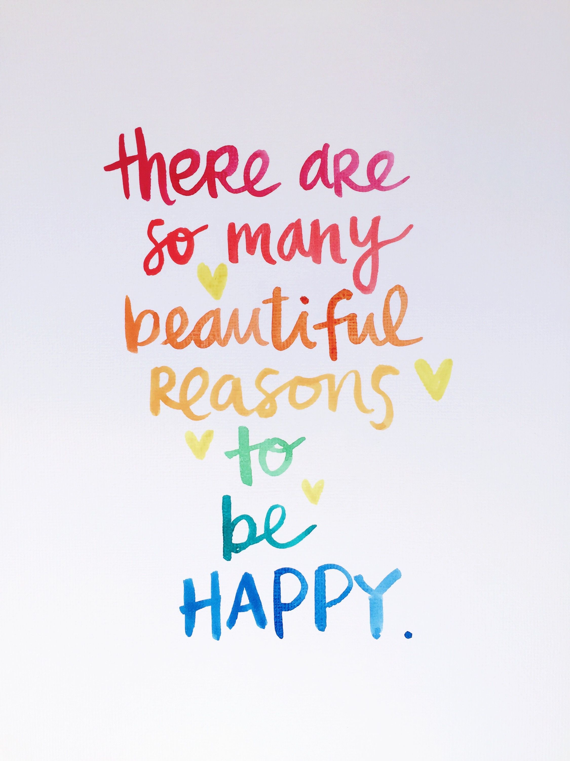

*First of all, please change the definition of* ***HAPPINESS*** *in your minds.* ***HAPPINESS*** *is not the high marks you will get after studying hard, your promotion, that girl or boy next door.* ***HAPPINESS*** *can never be found outside, the more you will search it in outer world, the more disappointed you will return.* ***HAPPINESS IS SOMETHING THAT COMES FROM WITHIN.*** *Searching happiness in outer world is a mirage, it doesn't exist. Now the question might arise in your mind that how will I ignite happiness within myself.*

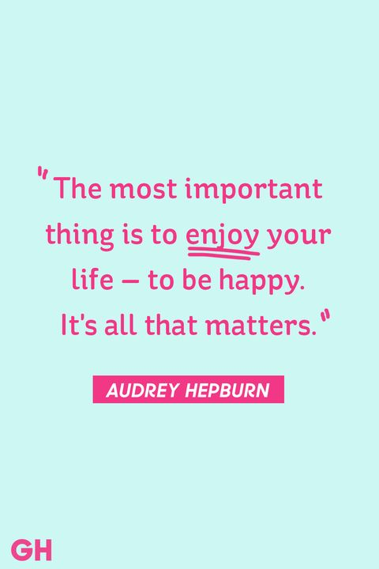

*So here we will let you know how to ignite it back. Have you ever seen a baby or a young kid playing? They always play alone without caring about anybody out there, they ask you once or twice and if you disagree to play with them, they will manage playing and enjoying alone. So what can we learn? We can learn that you should be so happy with your own self that nobody out there really matters to such an extent that they could ruin your peace.*

*Do you remember that smile on your face when the very first time you balanced your cycle without falling even once or do you remember your father's proud eyes when you got your first medal at that event. You must have become nostalgic now. So if we could have been happy after such little goals then how can we forget that now?*

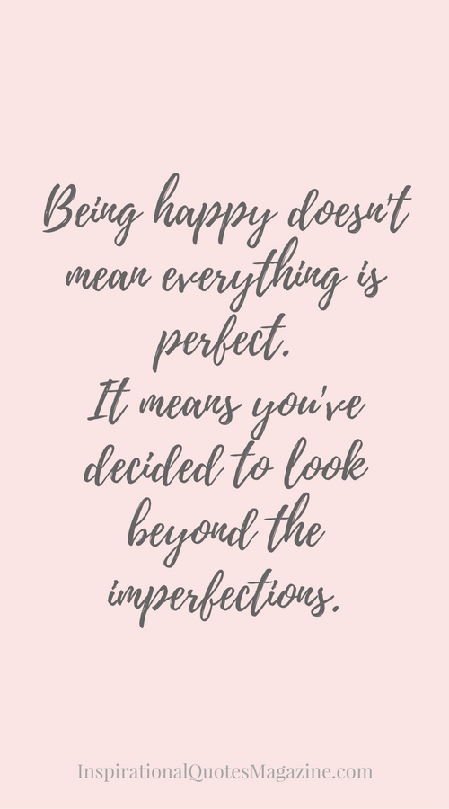

***Pay attention to little things around you, they will amaze you with so happy beauties that you will not need anybody out there to make you happy. Even in lockdown you can set short goals for yourself and then see how that true smile will return when you will successfully complete those goals. It's just about your perspective and you can experience hell and heaven on Earth only.***

***Some small joys which you can experience everyday are-***

***• The smile on your mother's face when you compliment her for food.***

***• The hidden proud of your father when you will discuss your future goals with him***

***• The pretty smirk on your sister's face when she will be successful in teasing you.***

***• The laughter with your brother when you both succeed a game together.***

***• The voice of birds chirping early morning.***

***• The silence and peace at night***

***• The contentment within you when you will again dance today on that old fav dance song of yours.***

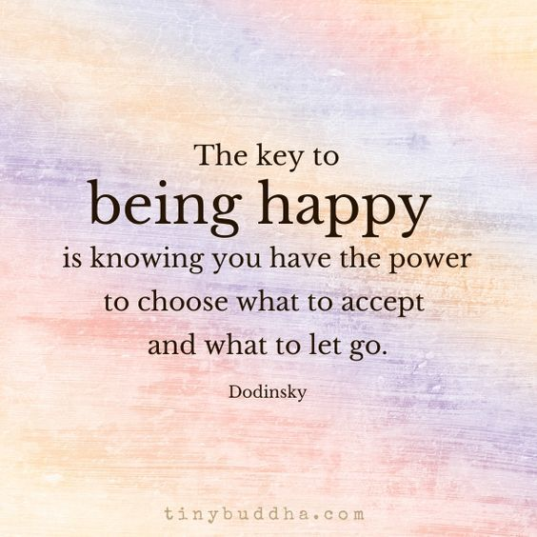

*There can be many more, just search around, just give yourself a chance to be happy. And I would end by saying my favorite dialogue from "****Kal ho na ho". "Haso, jiyo, muskurao, kya pta kal ho na ho****." In English, "****Laugh, live, smile, who knows will there be a tomorrow or not."***

*"****Create your heaven on Earth and walk through it every time life bangs you with it's hell. " ~Rakhi***